Docker TASK 3:
Create a custom docker image for nginx and deploy it using docker compose, where the volume bind mount should be at /var/opt/nginx location. Push the created custom docker image to your docker-hub.
Created the nginx-custom folder and created the custom index file

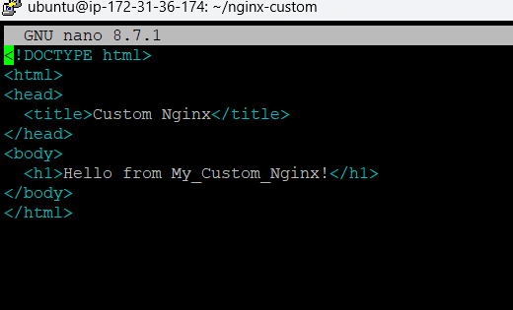

Build the Custom Image
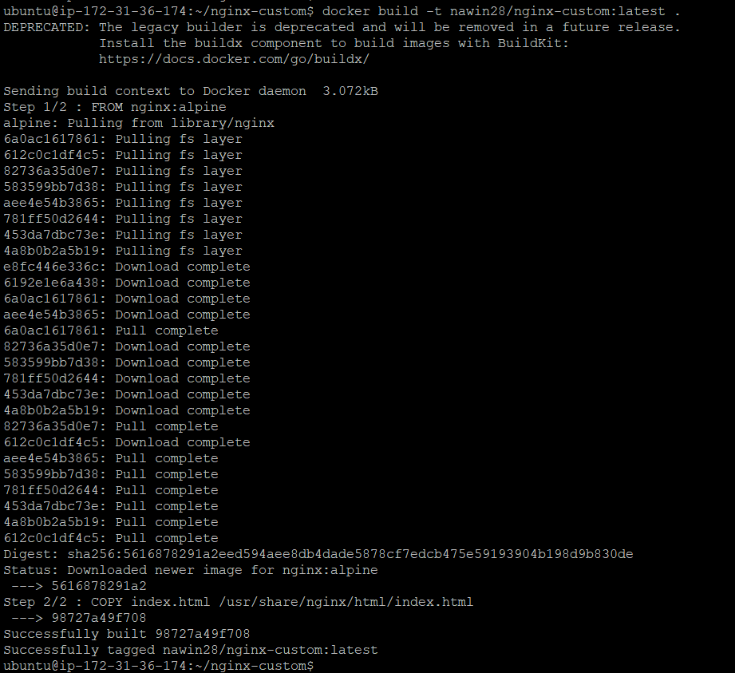

Login the Docker Hub and Push the image to DOCKER HUB
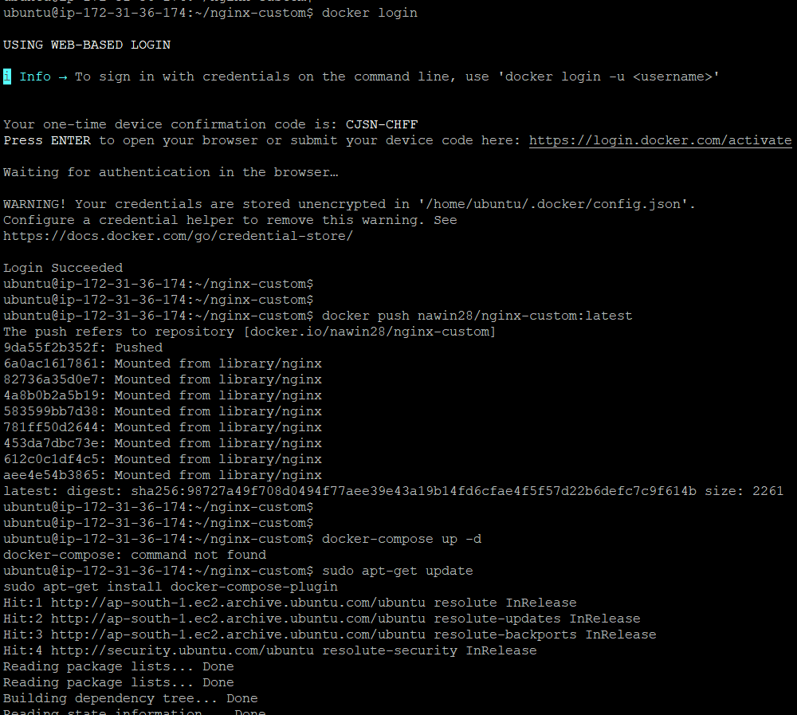
Docker Compose File Creation
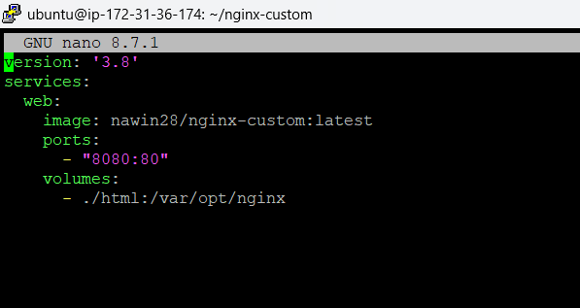
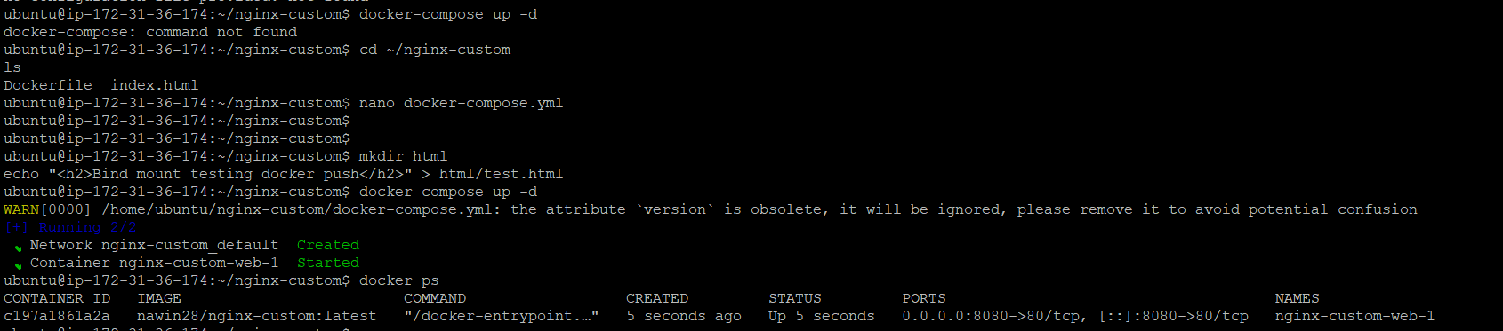

OUTPUTS:
